Dr. Simon A. Roberts
10/466 Illawarra Rd
Marrickville South, NSW, 2204
+61-432-037-784
simon@snails.email

Mr. Brian Heath
16 Phoneix Close
Jerrabomberra, NSW, 2619
Australia

06/12/17

Too Brian Heath,

Greeting Brain I mean Brian how have you been, I thought I would reconnect some missing contacts in your phonefiler, as I understand this loop in time you have either lost contact or never at this point met in this historical corridor parralax the Roberts clan of Asquith, NSW, 2207. I understand you and Neill have been close for some time and he is an wayward man that when you if ever had close bonds with him, it is very easy even in a silent moment to reunion with him.

Firstly I will give you some contact information:

Neill Anthony Roberts <neillr64@gmail.com> ~ +61-409-916-460

Annette Lee Roberts <netnotes@bigpond.net> ~ +61-409-811-410

41 Amor St, Asquith, NSW, 2207, Australia ~ +61-2-9482-1974 (secure)
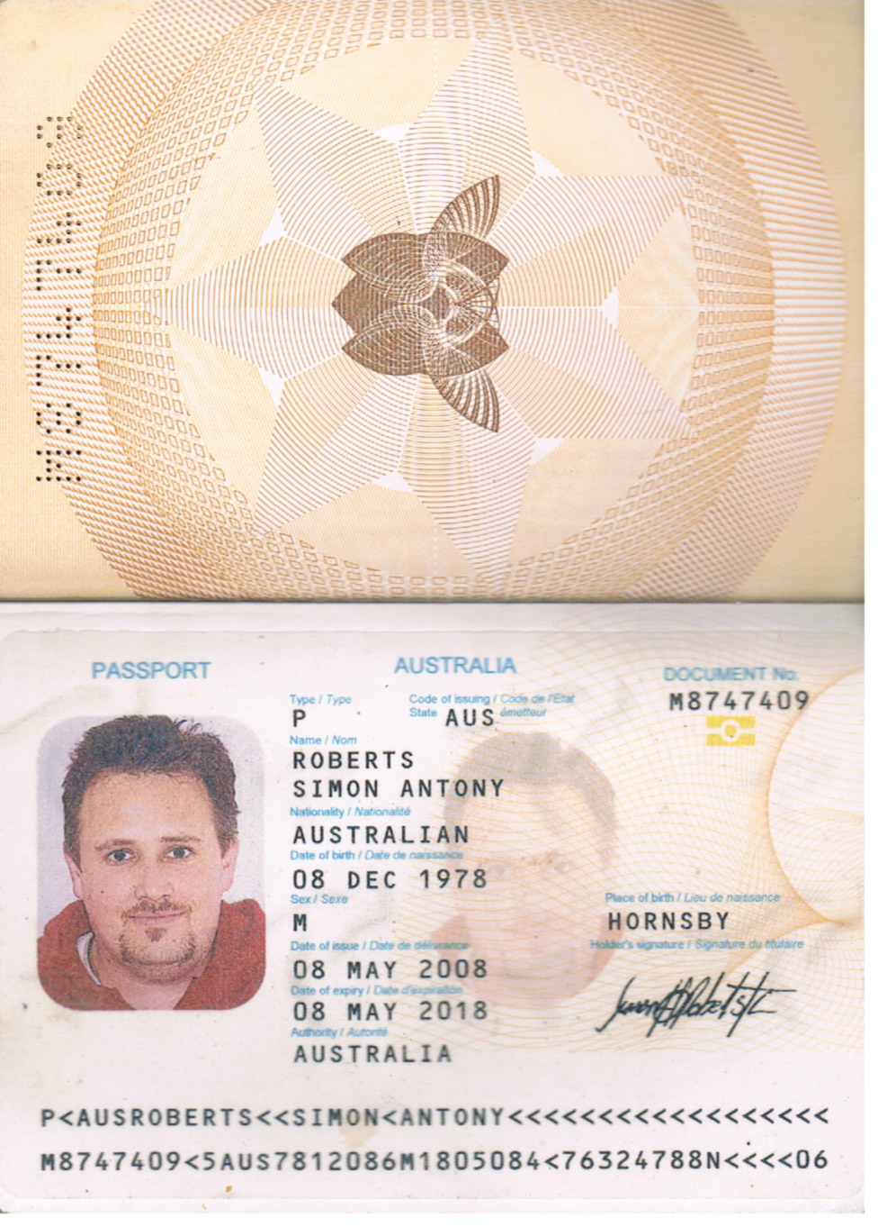
Well what have I been upto for quite a number of years I have been pushing myself through open university through RMIT and have since 2008 as formally titled Doctor, a masters in IT, Physics + Psychology making me a qualified psychiatrist, I listed with medicine san`frontier as a psychiatrist who asked me to stay in NSW for the moment. I am having problems with NSW health respecting my qualifications though as they constantly are injecting me with anti-psychotics but that course I have done automatically even after being awarded it defers to IT, Physics + Social if I am ever mentally ill in psychometry so I am slowly persuing medico-legal with drlucire.com → I believe your diagnosis is false as well and subject to the following passport, that was only for the first time in some many historical corridors of being back-here-again somehow in the metric of the internet being utilised your backside for a depo just purely for purposes of the health system and their ebay purchases and so on getting refunds and attempting to write in trys for gambling (TRY = Touchdown Region Y’all – flashes up on the NRL Scoreboard at spectator games), that is all that TLA is.

Whatelse, well I have stopped using all forms of Microsoft, I don’t like the physicality as much as what I found a derivative of Debian linux called Ubuntu in it desktop variegate is like, it is pure bliss, I don’t even allow microsoft to power up on my home environment anymore (you can get the ISO from http://releases.ubuntu.com) I really recommend you delete your windows laptop and load this on it, it is such a good performer and is self written that is her writes herself in AI’s and so on so there is no programmer physicality in the run-time of it, it is absolutely bliss, an not only sounds better but is visually and just generally an ideal platform, at no cost and a hell of a lot more people power as well as quality of titles available for it is the most best thing I have ever done move away from close source to open source, general public licensed software, which is also what I am developing for xoops.org <wishcraft>.

I attempted to write Justin a couple of times, about releasing music on locked USB keys like similar too a crass distribution under creative commons licensing, and with a text file with discount codes for merchandise, which is the only way you make money in retail is not the medium in this instant art/music but your addon sales like the t-shirt that cost $1.50 to print on mass, with sale price of 35 AUD and shipping $4, it is much better than and more money effective if you do it this way than scraping the microcents for Itunes or Google Music sales, plus people have a USB key that plays in the car stereo in the reliving reinvention of the cassette tape, and a locked USB out of china at what 1Gb/2Gb would only cost printing 50c - $2 and you can have art, poems, photos, music in MP3, ogg, as well as a wide range of text files and supportive mediums for the shop online with the discount code that prompt buying their t-shirt.

Well I could go on but I will leave you with some links to explore my gmail is conquebine@gmail.com if simon@snails.email is ever down, but I did make you a little ayahusca physicality safety email address for private maile called brian@snails.email the password is j0nJ7z-- details for the service are as follows:

imap.snails.email (ssl: imap.partnerconsole.net)
smtp.snails.email (ssl: smtp.partnerconsole.net)
webmail.snails.email

These are my following links so you can explore and connect to my profiles if you wish, should be safe for you on Ubuntu, recommend it for quality of sound and visual and performance to people, they wont be able to go wrong with it…

https://twitter.com/SimonXaies
https://twitter.com/ChronolabsCoop
https://facebook.com/mynamesnot
https://facebook.com/ChronolabsCoop
https://github.com/Chronolabs-Cooperative
https://sourceforge.net/p/chronolabs-cooperative
…
Just to name a few

and with that I leave you with a photo of my cat – Meow Meow Twerp

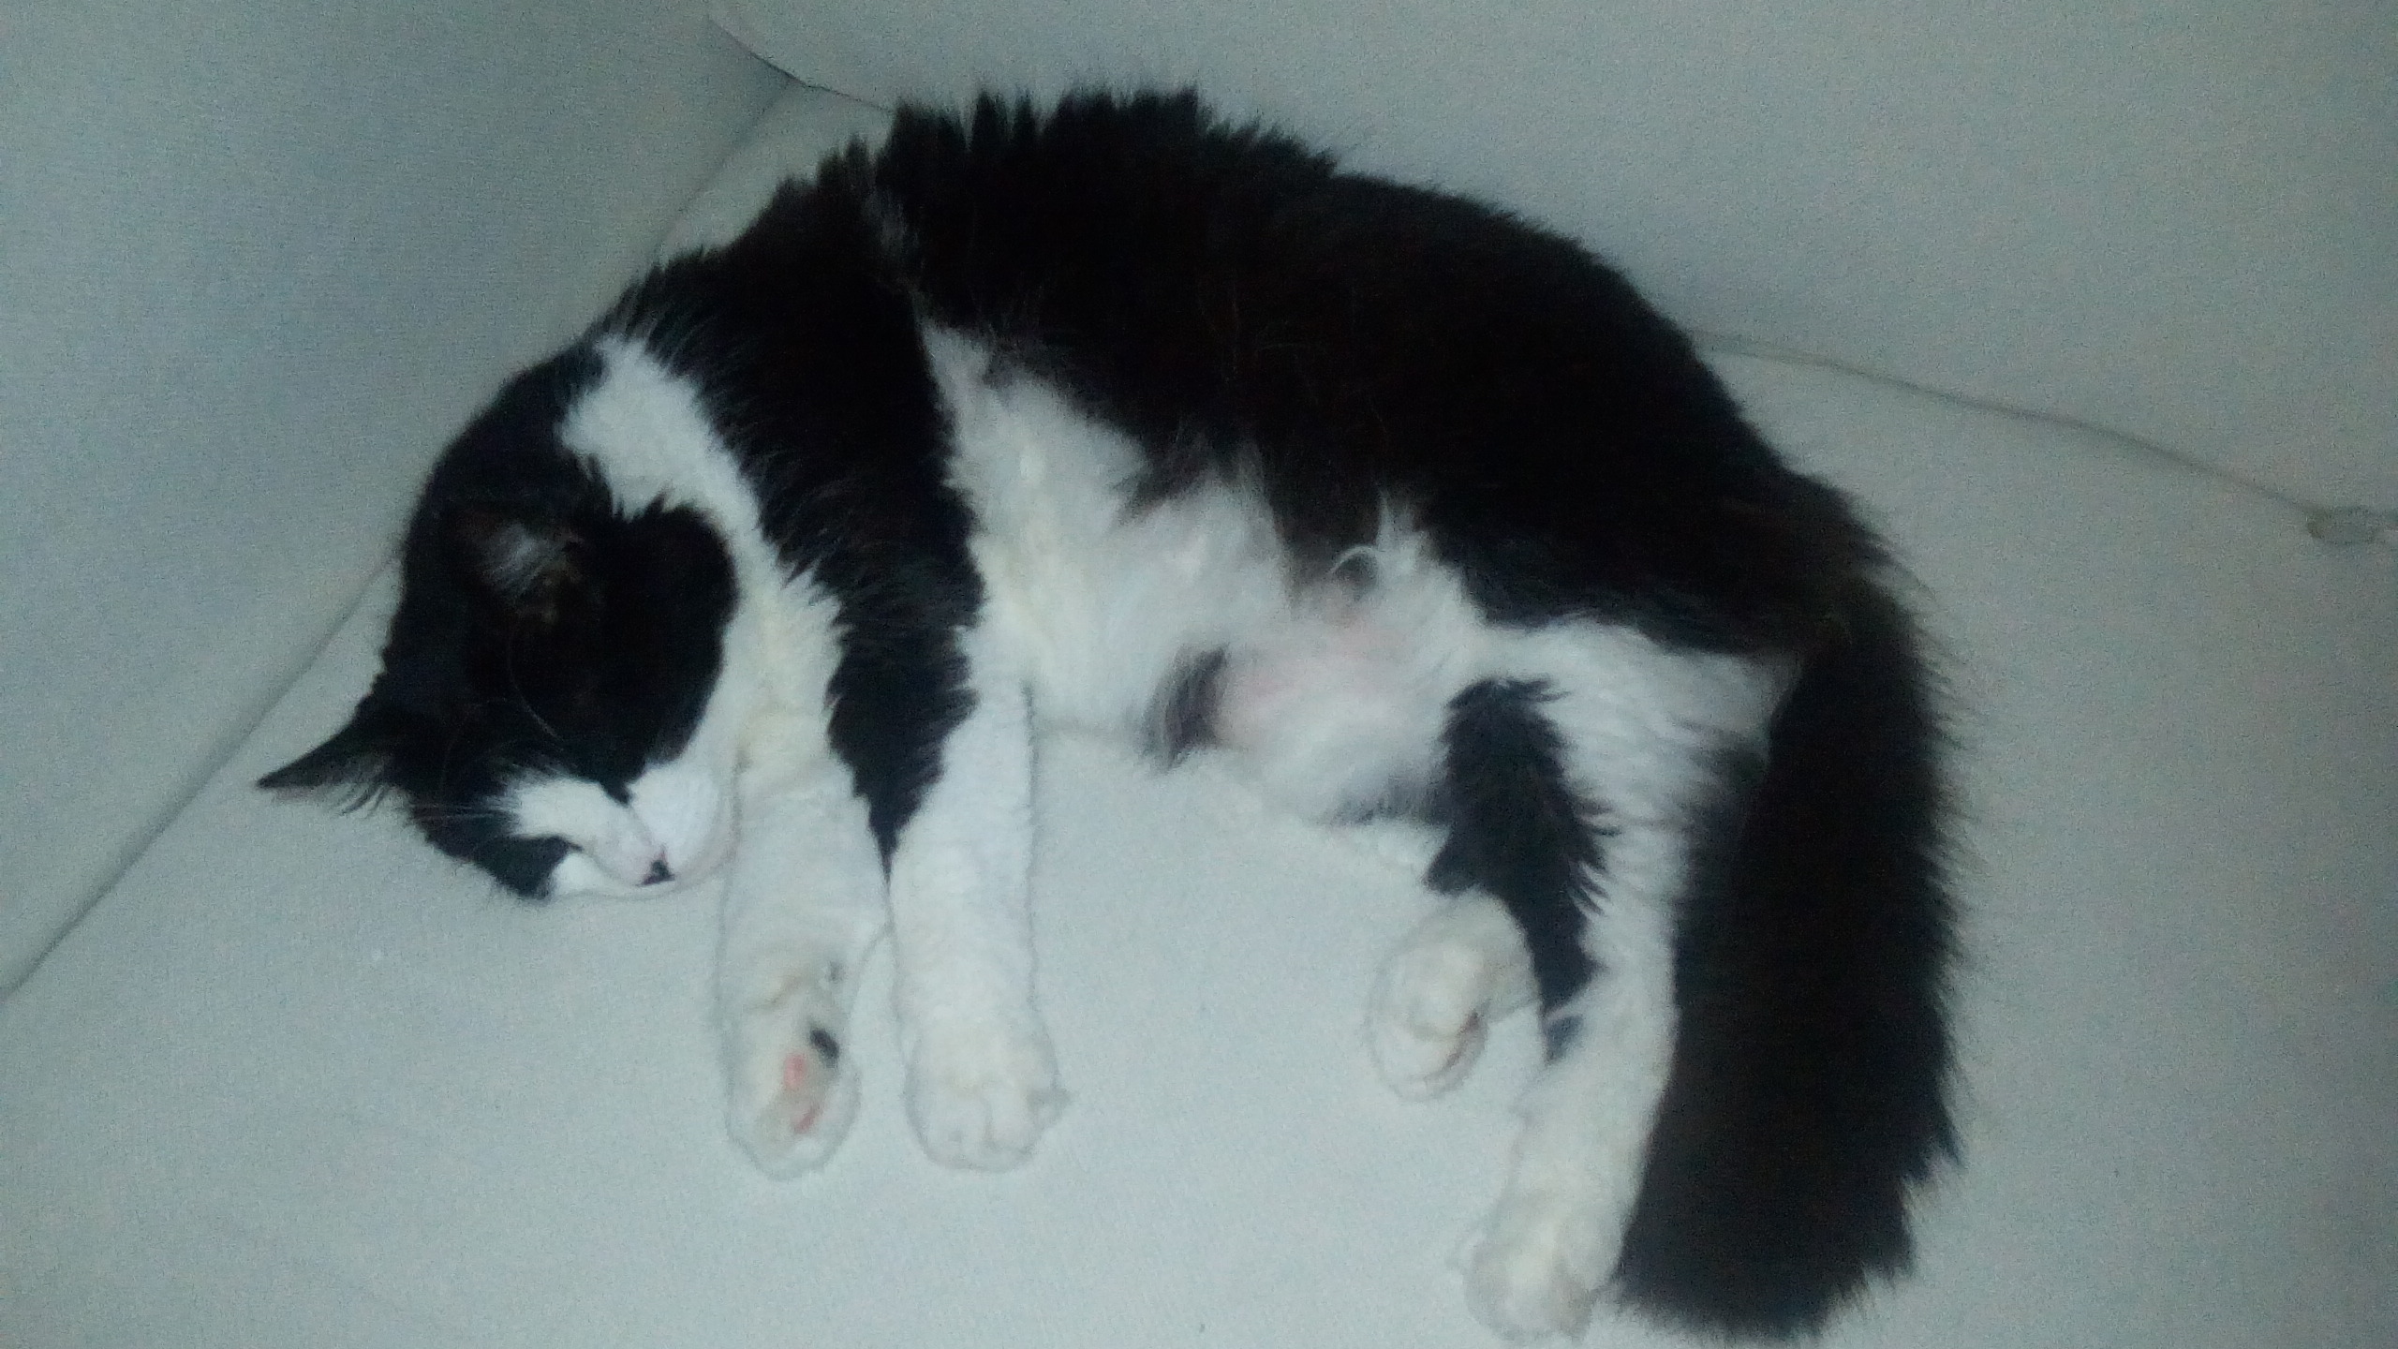
This is our other cat her daughter also a pomigrange

Vincent Mozerella Twerp (Elpiniki Iosif [my wifes] Cat)
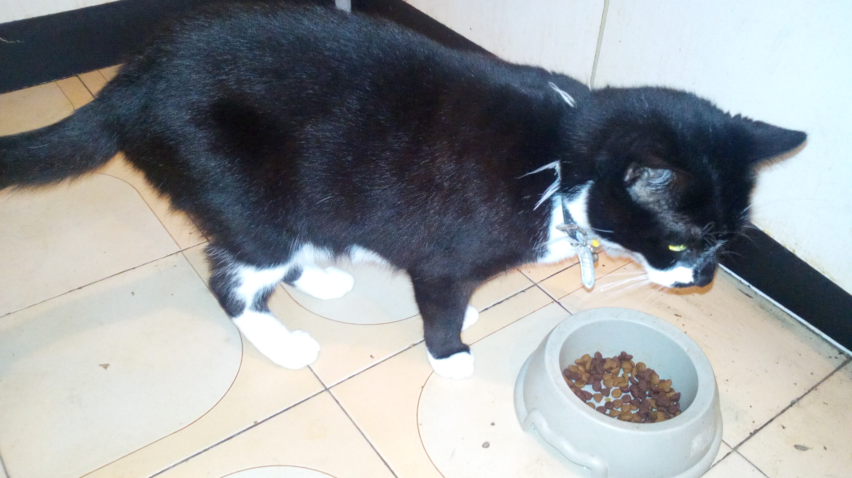

Kind Regard


Simon Antony Roberts
skype: antony.cipher
email: simon@snails.email
phone: +61-432-037-784

